ROLE:
Backup & Recovery Administrator
RESPONSIBILITIES:
1. Data Backup & Recovery
2. Recovery Monitoring & Failure Detection
3. Backup Storage Management

STEP 1 — CONNECT SYSTEM

STEP 2 — SWITCH CONTAINER
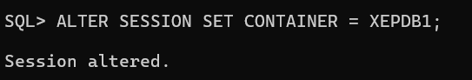

STEP 3 — CREATE TABLESPACE

STEP 4 — CREATE USER
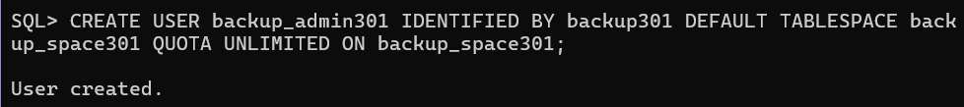

STEP 5 — CREATE ROLE
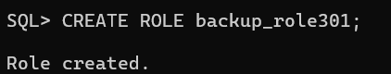

STEP 6 — GRANT PRIVILEGES TO ROLE
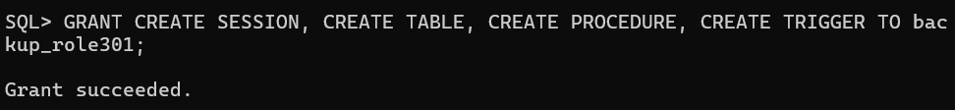

STEP 7 — ASSIGN ROLE
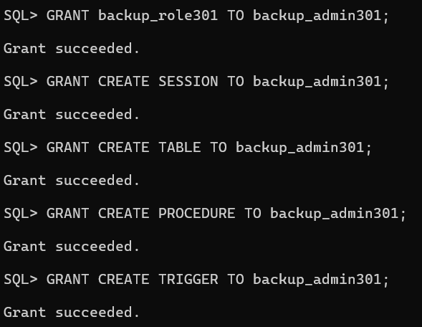

STEP 9 — CONNECT USER

VERIFY


STEP 10 — ENABLE OUTPUT

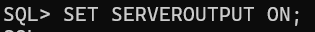

=====================================================

RESPONSIBILITY 1

DATA BACKUP & RECOVERY

NORMAL CASE
- created employee table
- inserted employee data
- created backup copy table
- logged successful backup

VIOLATION CASE
- accidental delete happened

DBA ACTION
- restored deleted record from backup table

DYNAMIC LOGGING

- trigger automatically detected deletion
- inserted log automatically

=====================================================

CREATE TABLE 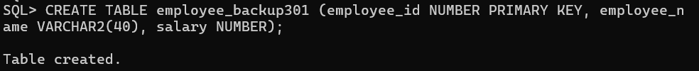

INSERT DATA

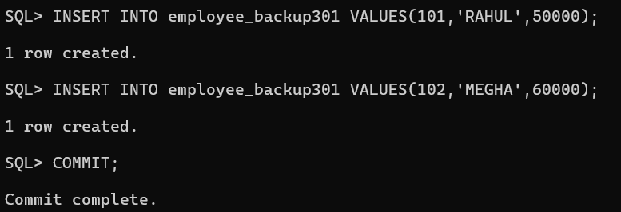

CREATE BACKUP TABLE:act as the backup storage

CREATE LOG TABLE : A successful backup operation is recorded inside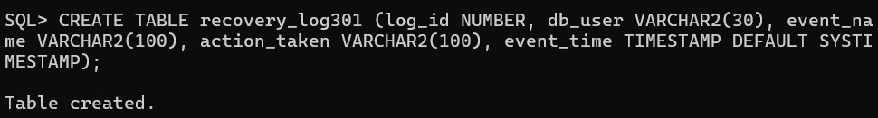

NORMAL CASE 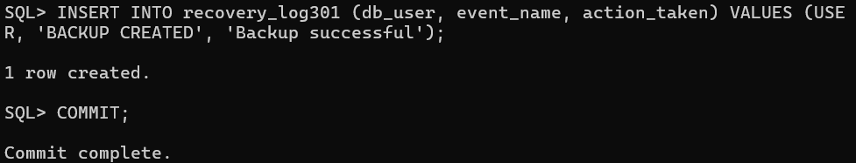

VIOLATION CASE

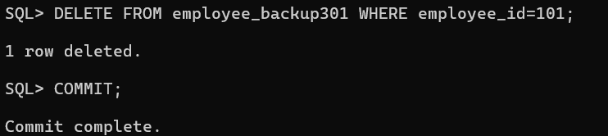

RECOVERY ACTION

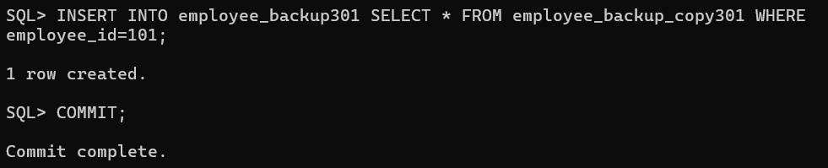

CREATE DYNAMIC TRIGGER

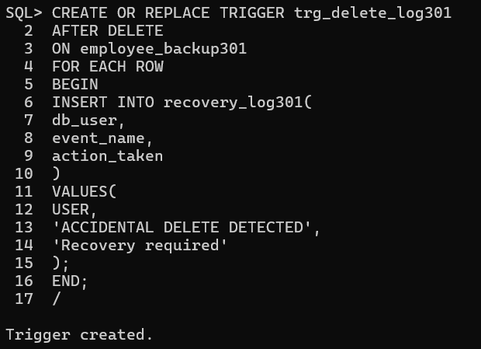

TEST AGAIN

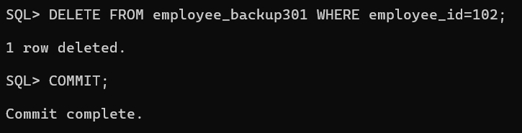

FINAL LOG

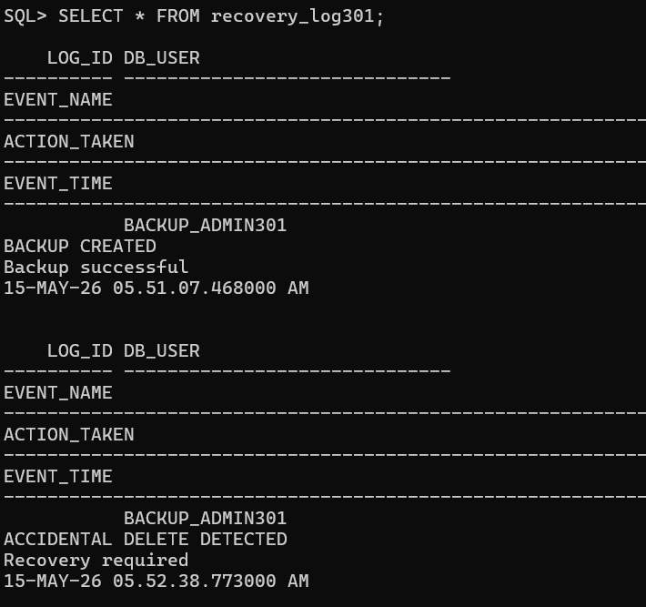

DBA RECOVERY ACTION

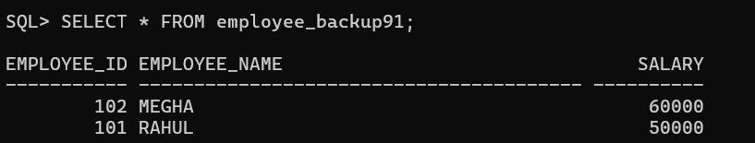

=====================================================

RESPONSIBILITY 2

RECOVERY MONITORING & FAILURE DETECTION

NORMAL CASE
- valid recovery status
- successful recovery monitoring

VIOLATION CASE
- corrupted backup recovery attempt
- recovery failure detected

DYNAMIC LOGGING
- failure log automatically inserted

DBA ACTION
- investigation required

STEP 1 — CREATE RECOVERY STATUS TABLE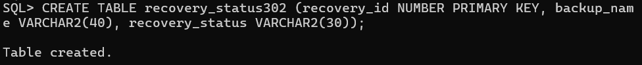

STEP 2 — CREATE FAILURE LOG TABLE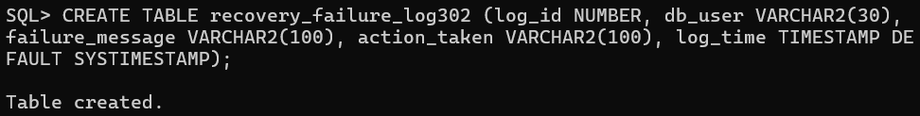

STEP 3 — CREATE PROCEDURE: automate recovery validation

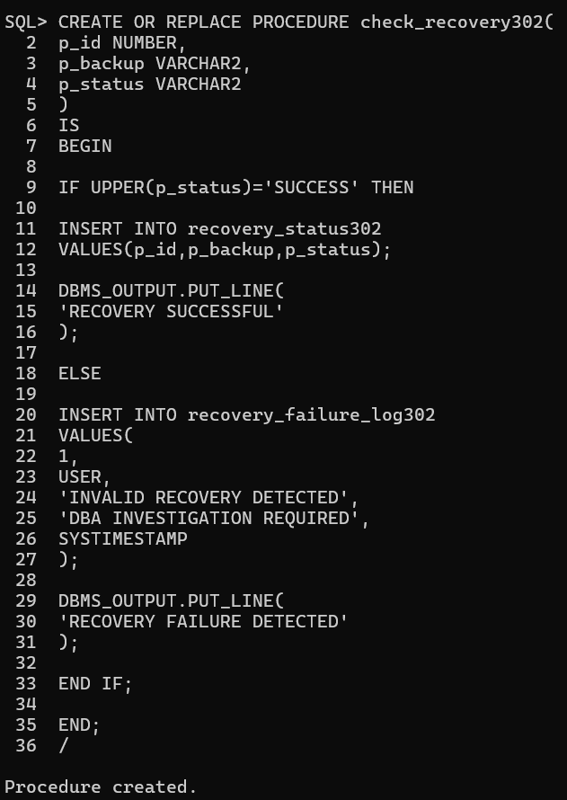

NORMAL CASE n CHECK TABLE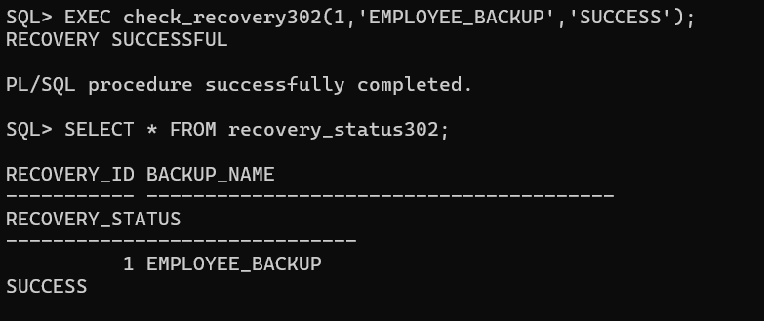

VIOLATION CASE n CHECK FAILURE LOG

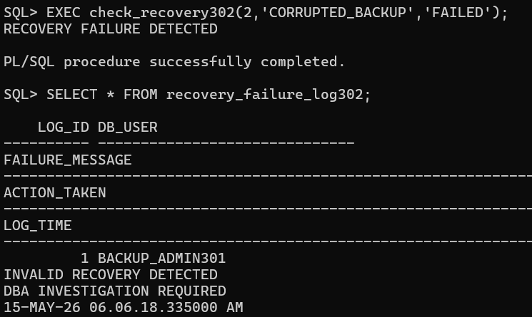

=====================================================

RESPONSIBILITY 3

BACKUP STORAGE MANAGEMENT

NORMAL CASE
- acceptable backup size inserted

VIOLATION CASE
- oversized backup attempted

TRIGGER ACTION
- insertion blocked automatically

DYNAMIC LOGGING
- storage violation log inserted

This is proper backup storage monitoring.
Pages 6–7 show this correctly.

=====================================================

STEP 1 — CREATE STORAGE TABLE: backup information, backup sizes

STEP 2 — CREATE STORAGE LOG TABLE: store oversized backup violations, store storage alerts, maintain backup storage audit logs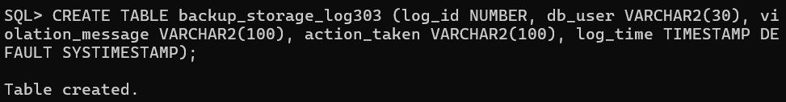

STEP 3 — CREATE STORAGE TRIGGER

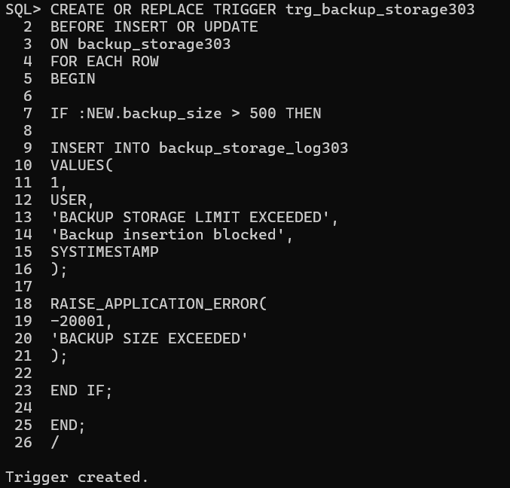

NORMAL CASE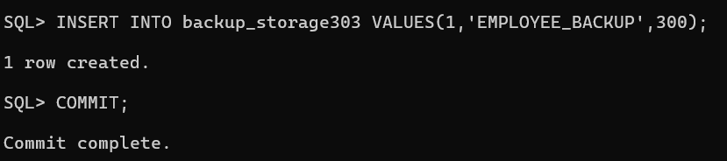

CHECK TABLE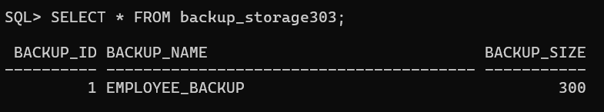

VIOLATION CASE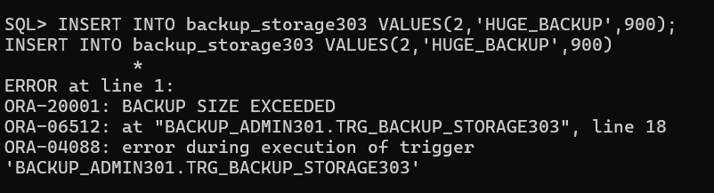

VIOLATION CHECK
